Whatever issue you are faced with, some steps are fundamental:
- Identify the problem
- Define the problem
- Examine the options
- Act on a plan
- Look at the consequences

This is the IDEAL model of problem-solving.
The final stage is to put the solution you have decided on into practice and check the results.

Developing your analytical and problem-solving skills
Most problem-solving skills are developed through everyday life and experience. However, the following interests and activities may be useful in demonstrating a high level of these skills - this may be particularly important when applying to employers in areas such as engineering, IT, operational research and some areas of finance.
- ‘Mind games’ such as cryptic crosswords, Sudoku, chess, bridge, etc;
- Computer games – the best of these can involve strategic planning, critical and statistical analysis and assessing the pros and cons of different courses of action;
- ‘Practical’ interests such as programming, computer repairs, car maintenance, or DIY;
- Working with sound or lighting equipment for a band, event or show;
- Academic study: evaluating different sources of information for essays, designing and constructing a ‘microshelter’ for an architecture project; setting up a lab experiment.

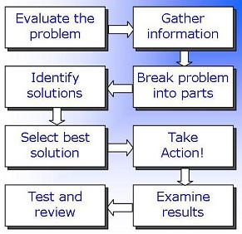
There are several stages to solving a problem:

1) Evaluating the problem
- Clarifying the nature of a problem
- Formulating questions
- Gathering information systematically
- Collating and organising data
- Condensing and summarising information
- Defining the desired objective

2) Managing the problem
- Using the information gathered effectively
- Breaking down a problem into smaller, more manageable, parts
- Using techniques such as brainstorming and lateral thinking to consider options
- Analysing these options in greater depth
- Identifying steps that can be taken to achieve the objective

3) Decision-making
- deciding between the possible options for what action to take
- deciding on further information to be gathered before taking action
- deciding on resources (time, funding, staff etc) to be allocated to this problem
- See our page on decision-making skills

4) Resolving the problem
- Implementing action
- Providing information to other stakeholders; delegating tasks
- Reviewing progress

5) Examining the results
- Monitoring the outcome of the action taken
- Reviewing the problem and problem-solving process to avoid similar situations in future

At any stage of this process, it may be necessary to return to an earlier stage – for example, if further problems arise or if a solution does not appear to be working as desired.

